MMIS Tips for Accessing Clients Eligibility and Determining that the Correct Benefit Plan and Case Descriptors Match Up With UCMS.

Please note: If you F9 TWICE in UCMS this will send your update action over to MMIS in Real-Time; otherwise, you would need to check the following day to see that your action carried over to MMIS in order to view the client’s updated eligibility.

After logging in to MMIS you will see the tool bar shown below. Click on Recipient and then click Search.
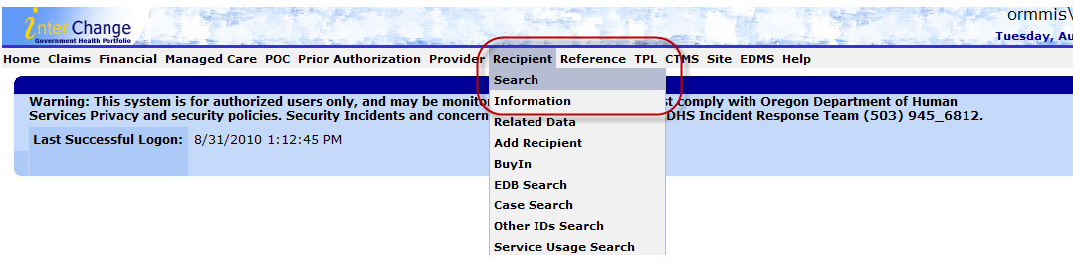

You will then see the Recipient Search fields. Please note that you can search by Prime (Current ID), Case ID (Case #), and by SS#, but searching by Prime is the most efficient search criteria.
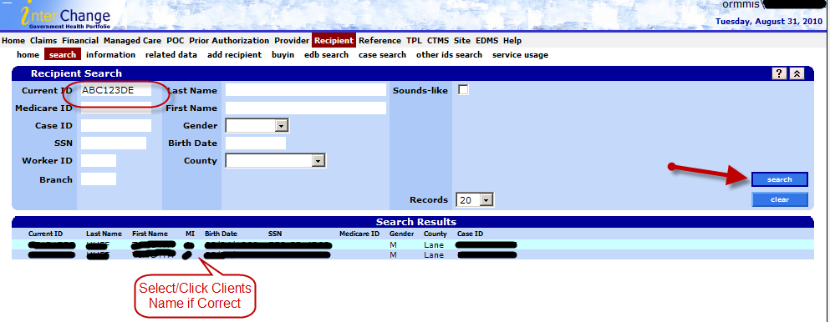
After you have selected the clients name the below page will display. Even though there is an eligibility and Managed Care Snapshot to the far right, it is best to proceed to the next step of selecting benefit plan at the bottom in order to get the full picture of the client’s eligibility.

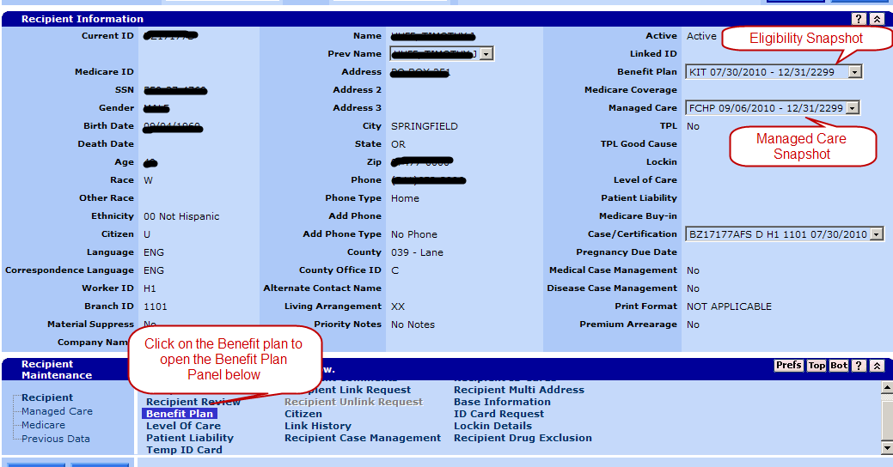

Once the benefit panel is opened up below the above image, you will notice a dropdown box and will want to select “Active Only.” After which, you will need to click search to the right as shown below.
Please note that after it has filtered just the Active lines you can manually filter by dates or benefit plan.

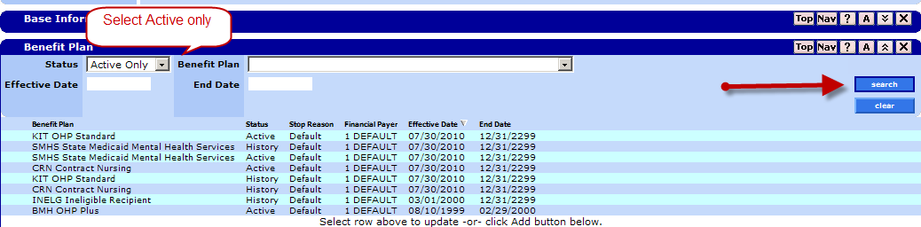
Lastly, click on the Benefit Plan that is most recent or for the time frame you are inquiring about. Once you have selected the benefit plan the Aid Category Panel then will display and you can click on the Aid category line to drill down the additional info and the Case Descriptors will also become visible.

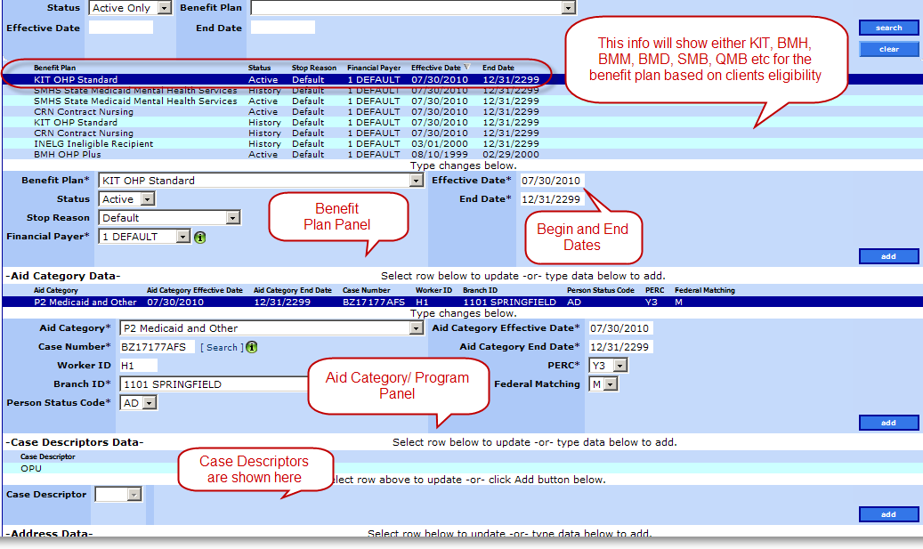

Benefit Packages and Their Respective Case Descriptors.

The following are examples of what you would look for in regards to what Benefit Package is associated with certain Case Descriptors.

Benefit Package – BMD – OHP with Limited Drug will have:
Case Descriptors of either: SBI, SMB, or SMF

Benefit Package – BMM – QMB + OHP w/Limited Drug will have:
Case Descriptor of: QMM

Benefit Package – MED – Qualified Medicare Beneficiary will have:
Case Descriptor of: QMB

Benefit package - KIT– OHP Standard will have:
Case Descriptor of: OPU

Benefit Package – BMH – OHP Plus will have:
Case Descriptors of: MAA, EXT, OPC, OP6, CHP, as well as others that are not listed above.

Benefit Package - SMB is a non-medical P2 case that pays premiums only

Benefit Package – SMF is a non-medical P2 case that pays premiums only

If you have further questions please contact CMU and we will do our best to help answer any questions and resolve any issues you may be facing.

CMU Phone – 503-378-4369

CMU Fax – 503-373-0357

CMU Email – client.maintenance@state.or.us

